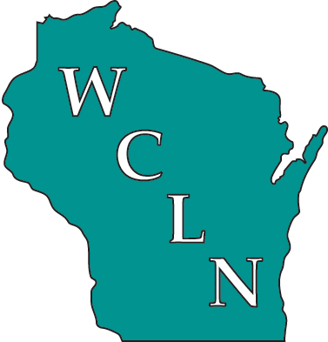
WISCONSIN CLINICAL
LABORATORY NETWORK (WCLN)

Statement of Purpose of the Wisconsin Clinical Laboratory Network (WCLN)
  - The purpose of the Wisconsin Clinical Laboratory Network (WCLN) is to provide communication channels and support to clinical laboratories. The WCLN will facilitate a timely and effective response to clinical laboratory and public health needs, including emergency preparedness, disease surveillance, laboratory diagnostics, training and education, and communications.
Expectations of WCLN Member Laboratories
  - WCLN member laboratories will:
- Share communications with colleagues and clients within and beyond their institutions, e.g., use of wcln listserver
- Maintain current points of contact for laboratory network communications
- Actively participate in WCLN regional meetings, teleconferences, workshops, and other activities
- Participate in laboratory-based surveillance (e.g., reporting data, providing isolates)
- Provide feedback and actively communicate needs (e.g., training needs) to laboratory network representatives
- Respond to the needs of other WCLN members (share resources, technical, etc.)
Expectations of the Wisconsin State Laboratory of Hygiene (WSLH)
  - The Wisconsin State Laboratory of Hygiene will:
- Coordinate laboratory network activities
- Provide or identify resources (written materials, shipping manuals, workshops, wcln listserver, etc.) to clinical laboratories (depending on availability of funding)
- Provide the communications mechanism for the Laboratory Messaging System
- Identify and respond to the needs of laboratory network members (depending on availability of funding)
- Maintain laboratory member contact information

