Purpose of the WCLN
- The purpose of the Wisconsin Clinical Laboratory Network (WCLN) is to provide communications and support to clinical laboratories. The WCLN will ensure a timely and effective response to clinical laboratory and public health needs, including emergency preparedness, disease surveillance, laboratory diagnostics, training and education, and communications.
WCLN Benefits &
Accomplishments
The WCLN has been strengthened by the involvement of laboratory representatives and by exercises, communications, and training and education activities and materials provided to laboratories by the WSLH.
Both clinical laboratories and the public health community have benefited from the WCLN. These benefits affect not only outbreak response, but also disease surveillance and the quality of laboratory services in Wisconsin.


Training and Education:
- Audio conferences are provided with continuing education credits at no cost to Wisconsin laboratories; topics are identified by laboratory personnel.
- “Continuing Education Resources for Wisconsin Laboratories”, an inventory of continuing education opportunities has been provided to laboratories.
- Technical workshops such as Gram stain and antimicrobial susceptibility testing are provided at no cost to participants.
Regional Meetings:
- Meetings addressing important laboratory issues are conducted annually at no cost to participants.
Communications:
- Laboratory contacts:
- Receive Laboratory System Messages with information updates, training announcements, and emergency notifications;
- Have the option to join a listserver for Wisconsin laboratorians.

Exercises - Testing:
- Bioterrorism Preparedness Educational Proficiency Exercises are offered twice per year at no cost to laboratories.
- Timed Communication Drills are conducted at least annually with clinical laboratories.
On-Site Laboratory Visits:
- WSLH staff visit selected laboratories each year to enhance relationships and discuss topics of concern.
Public Health Benefits:
- One of the benefits of the WCLN to public health is demonstrated by laboratory participation in surveillance, e.g., enteric pathogens that may be linked to foodborne outbreaks. Wisconsin does not mandate submission of enteric isolates, but submission rates are nearly 95% for reported cases of foodborne illness. Timely submission of isolates enables public health to detect and respond more rapidly to outbreaks, preventing additional cases.
Resource Materials Provided to Laboratories:
Posters: “Agents of Bioterrorism: Level A (Sentinel) Laboratory Guide”;
“APHL Bioterrorism Agents”
Quick Reference Testing Guide:
“Bench Guide for Bioterrorism Agents”
Laboratory Response Plan: “Wisconsin Emergency Response Guide for Clinical Laboratories”
Risk Assessment Guide: “Laboratory Biosafety: Performing a Risk Assessment”
Tick Identification Resource: “Guidelines for Tick Identification”
Emergency Laboratory Response Plan - template: “Laboratory Specific Emergency Response Plan”
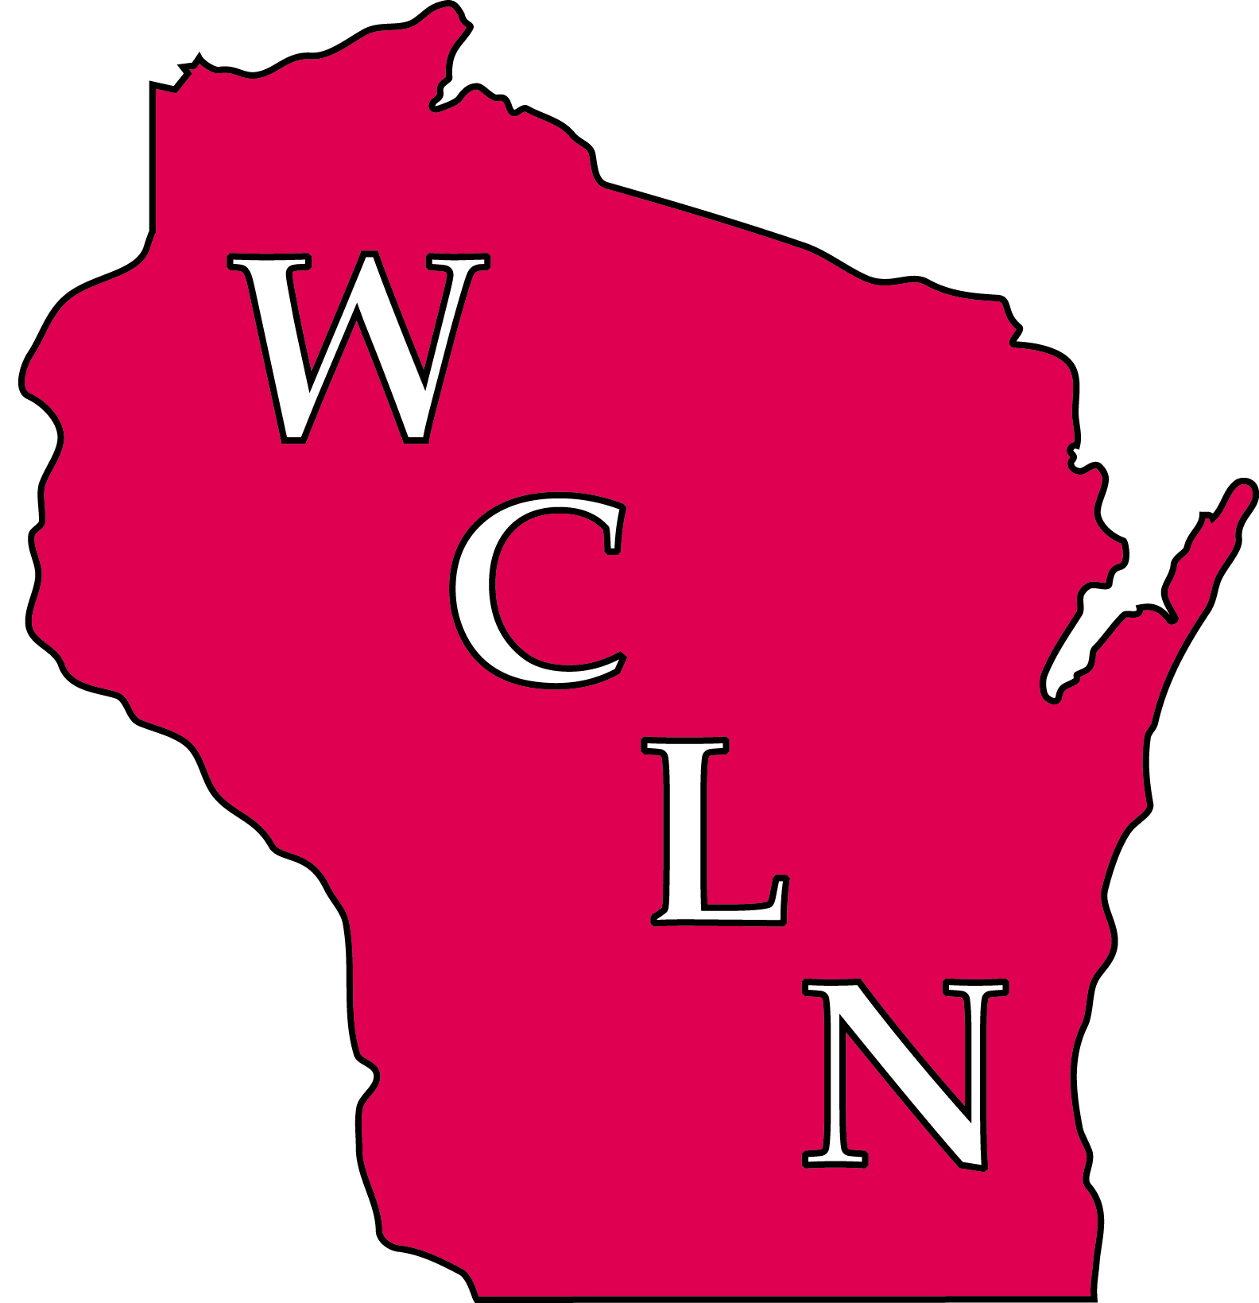

For on-line WCLN Resource Materials go to http://slhcmsprod/wcln-surveillance/wcln/wcln-resources/
Revised November 2013

Expectations of Member Laboratories

The Wisconsin Clinical Laboratory Network (WCLN)
The WCLN is a network of more than 130 clinical laboratories throughout Wisconsin. The Wisconsin State Laboratory of Hygiene (WSLH) coordinates the WCLN, which is a subset of the National Laboratory Response Network for bioterrorism (LRN), a voluntary network of laboratories able to respond to terrorism, emerging infectious diseases, and other public health threats or emergencies.
The LRN defines 3 levels of laboratories:
- National Laboratories
(e.g., the CDC)
- LRN Reference Laboratories (e.g, WSLH)
- Sentinel Laboratories (clinical laboratories, likely the first to recognize unusual occurrences)
- WCLN member laboratories will:
- Share communications with colleagues
- Maintain current points of contact for communications
- Actively participate in WCLN meetings, workshops, teleconferences, etc.
- Participate in laboratory-based surveillance
- Communicate training needs
- Respond to the needs of other WCLN members
Expectations of the WSLH
- The WSLH will:
- Coordinate laboratory network activities
- Provide or identify training resources for clinical laboratories
- Maintain the laboratory communications systems
- Identify and respond to the needs of laboratory network members

