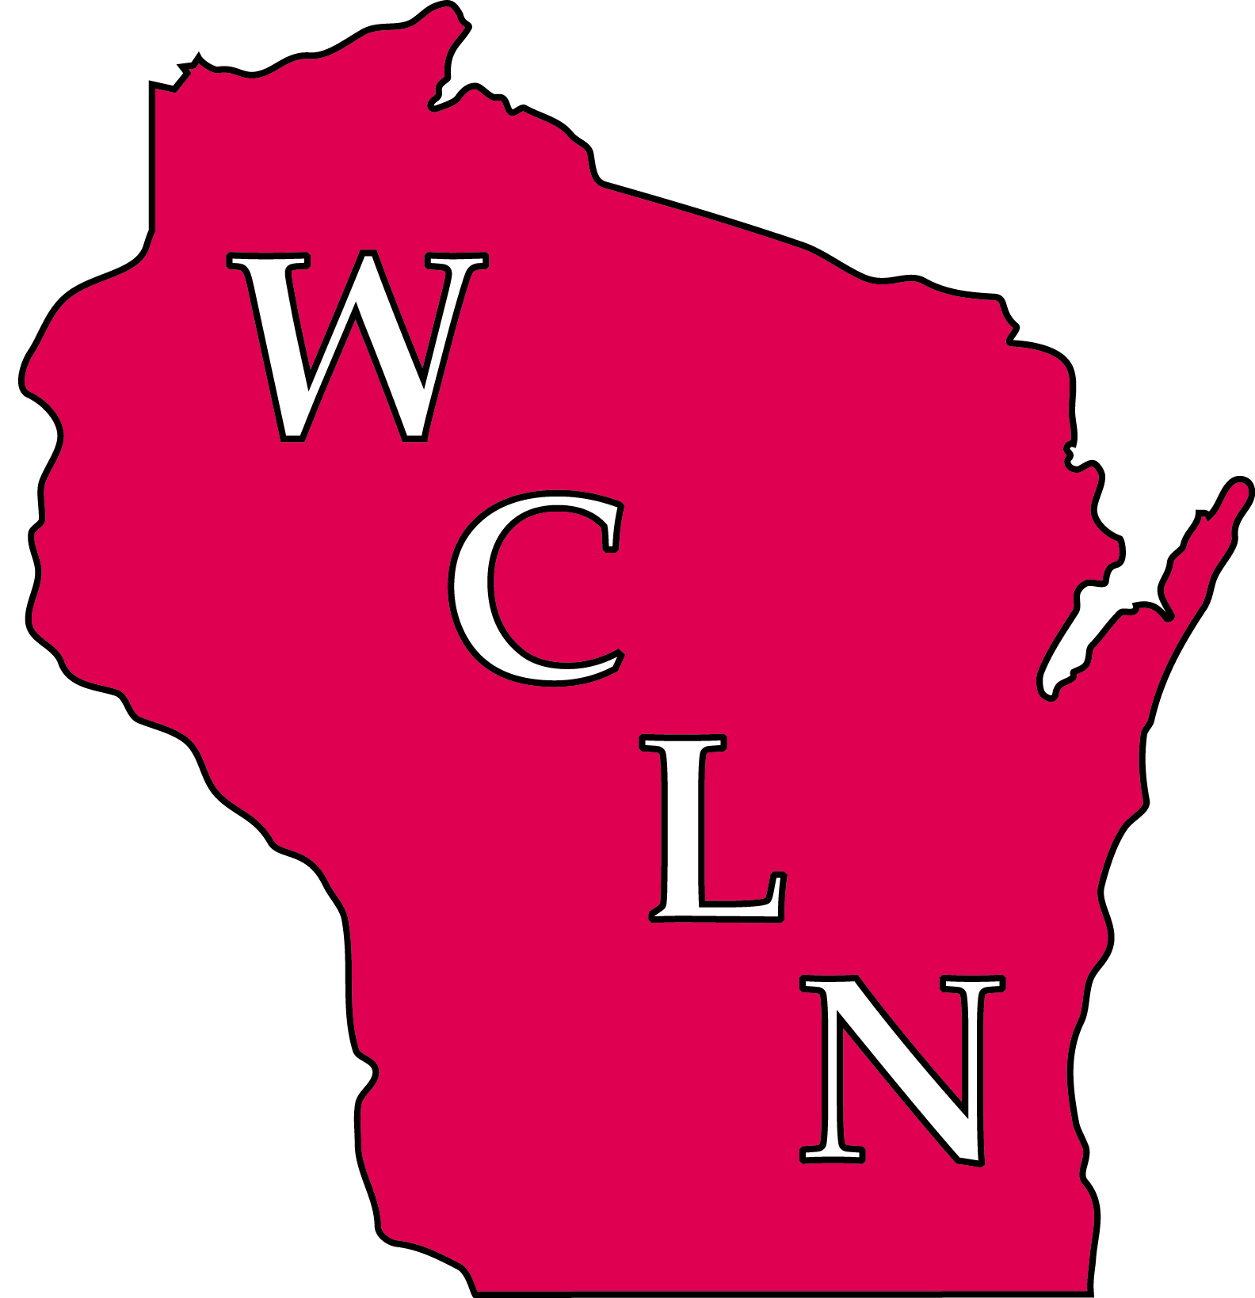

The Wisconsin Clinical Laboratory Network (WCLN)
The Wisconsin Clinical Laboratory Network (WCLN) is a network of approximately 135 clinical and laboratories throughout Wisconsin. The Wisconsin State Laboratory of Hygiene (WSLH) coordinates the WCLN, which is a subset of the National Laboratory Response Network for Bioterrorism (LRN).
The National LRN is a collaborative, voluntary network of laboratories for response to terrorism threats, emerging infectious diseases, and other public health threats or emergencies. Additional information about the LRN and laboratory roles is available at http://emergency.cdc.gov/lrn/. The National LRN defines 3 levels of laboratories, based on laboratory capabilities and responsibilities:
- National Laboratories, like the CDC, have extensive capabilities to characterize isolates and provide protocols and reagents.
- LRN Reference Laboratories, like the Wisconsin State Laboratory of Hygiene (WSLH), are responsible for providing reference level testing and coordinating the statewide networks.
- Sentinel Laboratories are comprised of hospital-based and large clinical laboratories that perform some level of microbiology. Sentinel Laboratories are likely among the first that will recognize unusual occurrences and alert the rest of us.
In Wisconsin, the WCLN has been strengthened by materials provided to member laboratories, training and education activities, exercises, and communications, as described below. The WCLN has also been strengthened by involvement of laboratory representatives in the Wisconsin Clinical Laboratory Technical Advisory Group and its committees.
Both clinical laboratories and the public health community have benefited from the active participation of clinical laboratories in the WCLN. These benefits affect not only emergency response, but also disease surveillance and outbreak response.
If you want to know more about the WCLN or the information presented here, contact wcln@mail.slh.wisc.edu.

WCLN Accomplishments
Resource Materials Provided to Laboratories:
Posters: “Agents of Bioterrorism: Level A (Sentinel) Laboratory Guide” and “APHL Bioterrorism Agents”
Quick Reference Testing Guide: “Bench Guide for Bioterrorism Agents”
Laboratory Response Plan: “Wisconsin Emergency Response Guide for Clinical Laboratories”
Risk Assessment Guide: “Laboratory Biosafety: Performing a Risk Assessment”
Tick Identification Resource: “Guidelines for Tick Identification”
Emergency Laboratory Response Plan – (template): “Laboratory Specific Emergency Response Plan”
Regional Meetings: Conducted annually since 2003 at no cost to participants
On-Site Laboratory Visits: WSLH staff conduct laboratory visits each year to enhance relationships and identify and discuss topics of concern.
Exercises - Testing: Bioterrorism Preparedness Educational Proficiency Exercises are offered at no cost to all laboratories twice per year as well as annual Communication Drills
Workshops: Technical workshops such as Gram stain and antimicrobial susceptibility testing for Wisconsin laboratorians have been provided at no cost to participants.
Communications: At least two contacts at each WCLN laboratory receive “Laboratory System Messages”, which contain information updates, training announcements, and emergency notifications. In addition, a listserv has been developed to enhance communication and information-sharing among Wisconsin laboratorians.
Training and Education: Audio conferences are provided at no cost to Wisconsin laboratories since January, 2003, providing continuing education credits and training in topics identified by laboratory personnel. In addition, “Continuing Education Resources for Wisconsin Laboratories”, an inventory of continuing education opportunities has been provided to laboratories.

