Facility/Agency Name: ______________________________________________City & Zip: __________________________________

Staying for Lunch? **⬜ Yes If registering multiple people, how many are staying for lunch ? _________________**

**⬜ No**

***“From the WSLH with Love”***

***(OO7 Visits the Laboratory)***

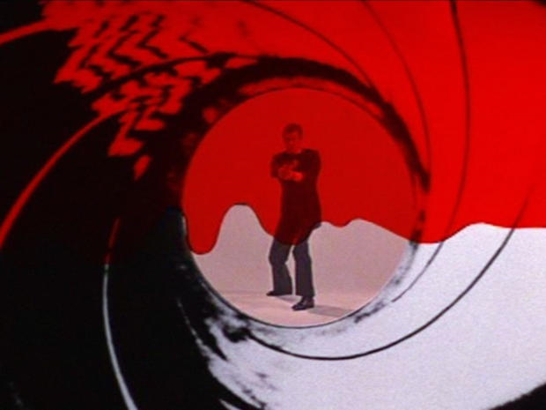

**October 13**

**Rice Lake, WI**

**October 14**

**Kimberly, WI**

**October 16**

**Wisconsin Dells, WI**

## *Wisconsin Clinical Laboratory Network*

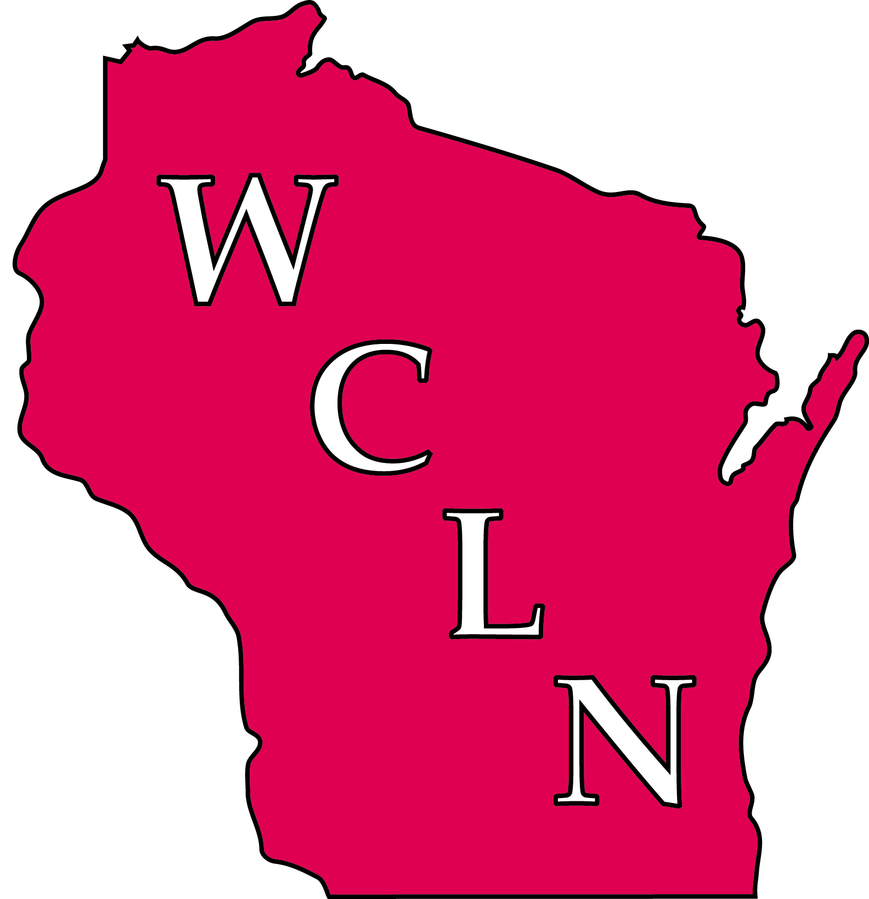

***2015 Regional Meetings***

***“From the WSLH with Love”***



**Meeting Coordinator:**

**Erin Bowles /** [erin.bowles@slh.wisc.edu](mailto:erin.bowles@slh.wisc.edu), Phone: 608-890-1616

***Questions?*** Email: [wcln@mail.slh.wisc.edu](mailto:wcln@mail.slh.wisc.edu), Phone: 608-890-1616

**Fax Registration Form**

**2015 Regional Meetings of the Wisconsin Clinical Laboratory Network**

Please check the meeting date that you/your staff plan to attend and fax the completed form to:

WCLN – Regional Meeting, 608-265-9091

***Please check desired meeting date/location:***

**⬜ October 13 – Rice Lake, WI**

Turtleback Golf, Dining & Conference Center, 1985 18 ½ St.

**⬜ October 14 – Kimberly, WI**

Liberty Hall, 800 Eisenhower Dr.

**⬜ October 16 – Wisconsin Dells, WI**

Wintergreen Resort and Conference Center, 100 Gasser Rd.

A confirmation of registration will be sent via email prior to the meeting date.

|  |  |  |  |  |
| --- | --- | --- | --- | --- |
| **Phone #** |  |  |  |  |
| **Email** |  |  |  |  |
| **Name and Title** |  |  |  |  |



**Wisconsin State Laboratory**

**of Hygiene**

**465 Henry Mall**

**Madison, WI 53706**



## Wisconsin Clinical Laboratory Network

***(formerly Wisconsin***

***Laboratory Response Network)***

**2008**

## Regional Meetings

***Wisconsin State Laboratory***

***of Hygiene***

**Program**

This one-day meeting presented by the Wisconsin State Laboratory of Hygiene (WSLH) offers clinical and public health laboratorians, infection preventionists and public health officers the chance to strengthen their relationships through networking and discussions of relevant laboratory issues.

The focus of this year’s meeting is Laboratory Preparedness and Laboratory Biosafety and Biosecurity. Are we ready for the next public health threat? What lessons have we learned from Ebola that we can apply to any emerging threat? How and why do we need to perform regular risk assessments in our laboratories to improve our culture of laboratory biosafety/biosecurity? Other topics of discussion rounding out the day are CRE, IQCP and the ever popular case studies.

We have structured the day so that our guests from Infection Prevention and Local Public Health may choose to leave after lunch when the presentations will be entirely focused on more technical laboratory issues.

**Target Audience**

**This meeting is intended for all laboratory scientists. We especially want to encourage laboratory management to attend** as we work to improve the Culture of Biosafety and Biosecurity in our WI laboratories.

**We also invite Infection Prevention and Local Public Health to join the laboratory for the morning presentations and for lunch** to enhance communications among the laboratory, health care and public health communities.

**Speakers**

**Peter Shult, Ph.D.**

Director, Communicable Disease Division & Emergency Lab Response

**David Warshauer, Ph.D., D(ABMM)**

Deputy Director, Communicable Disease Division

**Erin Bowles, B.S., MT(ASCP)**

Laboratory Network Coordinator

**Special guest speakers:**

Representatives from LabTag, WCLN laboratories, and the Wisconsin Division of Public Health,

**2015 WCLN Regional Meetings**

**“*From the WSLH with Love*”**

**(OO7 Visits the Laboratory)**

**Agenda:**

7:45 (Registration & Refreshments)

8:20 “***Goldeneye”*…**

(Welcome & Introductions)

8:30 “***Thunderball”*…**

(Are We Prepared for the Next Public Health Threat?)

10:00 (Break)

10:15 “***Die Another Day”…***

(Battling CRE: Impact of the New Definition and Other Issues)

11:15 “***For Your Eyes Only”…***

(Case Studies)

12:00 “***Quantum of Solace”…***(Lunch)

1:00 “***A View To A Kill”…***

*(Avoiding Hazards through Risk Assessment)*

2:00 (Break)

2:15 “***Licence To Kill”…***

(Beating the Bad Guys through Bioterrorism Exercises)

2:45 “***You Only Live Twice”…***

(IQCP or CLIA QC)

3:15 ***“Tomorrow Never Dies”…*** (Wrap-up and Adjourn)



**P.A.C.E® Credits**

A certificate of participation will be granted to each participant based on 5.5 contact hours of instruction toward credit.

This program is co-sponsored by ASCLS-WI, an approved provider of continuing education programs in the clinical laboratory sciences by the ASCLS P.A.C.E.€® Program.

**Special Needs**

In compliance with the Americans with Disabilities Act (ADA), individuals requiring special accommodations must notify the program coordinator no later than two weeks prior to the meeting date selected.

**Registration**

**Regional meetings are offered at no charge, with lunch and morning and afternoon refreshments provided.**

Pre-registration is required. A confirmation of registration will be sent via email prior to the scheduled meeting date.

Registration is available either online (**preferred**) or by fax.

**To Register Online:**

Register online at the WSLH website under **“*Upcoming Training Events***” at:

[**http://www.slh.wisc.edu/wcln-surveillance/training/**](http://www.slh.wisc.edu/wcln-surveillance/training/)

or at the following direct link:

[**http://www.surveygizmo.com/s3/2227222/2015-WCLN-RM**](http://www.surveygizmo.com/s3/2227222/2015-WCLN-RM)

**To Register by Fax:**

Complete the registration form and fax to:

**WCLN– Regional Meeting**

**Fax: 608-265-9091**

**Registration Deadline**

**October 5, 2015**

