*Gram Stain*

*Fundamentals*

*2016*

A Wet Workshop

for

Wisconsin Laboratories

**July 22, 2016**

**Northcentral**

**Technical College**

**Wausau, WI**



**Wisconsin Clinical**

**Laboratory Network**

***Gram Stain Fundamentals - 2016***

**A Wet Workshop for**

**Wisconsin Laboratories**

**Workshop Date:**

July 22, 2016

**Workshop Location:**

Northcentral

Technical College

1000 W. Campus Drive

Wausau, Wisconsin

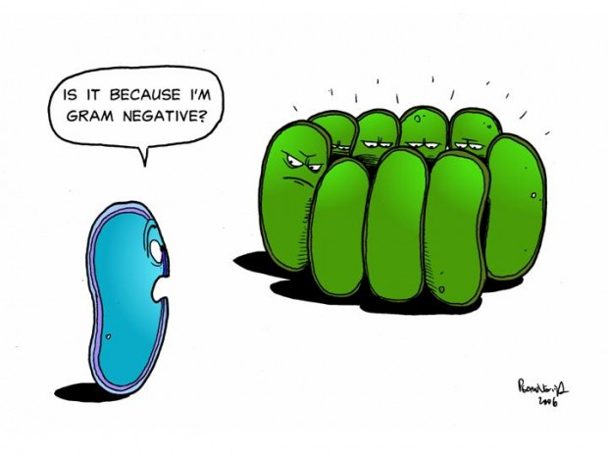



465 Henry Mall

Madison, Wisconsin 53706

*Gram Stain Fundamentals - 2016*

Registration Form

Fax completed form to

WSLH – Workshop

Fax: 608-265-9091

by July 8, 2016

**Name:**

_________________________

**Laboratory:**

__________________________

**Address:**

__________________________

**City:**

__________________________

**State:** **Zip:**

__________________________

**Telephone:**

__________________________

**Email Address:**

__________________________

**A confirmation of registration will be**

**sent via email prior to the workshop date.**

**……………………………………**

**Questions?**

Contact Erin Bowles

Email: [erin.bowles@slh.wisc.edu](mailto:erin.bowles@slh.wisc.edu)

Phone: (608) 890-1616



**Program**

This one half-day session is being presented by the Wisconsin State Laboratory of Hygiene for Wisconsin clinical laboratory professionals. The workshop will provide “hands on” training in Gram stain techniques used in clinical microbiology**. Class size is limited to 20 individuals.** The participants will be able to practice staining, reading and reporting Gram stains from clinical specimens. Quality control and troubleshooting techniques will also be discussed.

**Target Audience**

This workshop is intended for laboratory professionals currently working in a Wisconsin laboratory. **The workshop is designed to provide training to the “inexperienced” technologist or the “Generalist” who rotates through microbiology.** The workshop is not intended for the experienced technologist or microbiologist.

**Special Needs**

In compliance with the Americans with Disabilities Act (ADA), individuals requiring special accommodations must notify the program coordinator no later than one month prior to the workshop date.

**Materials Provided**

* Procedures for Gram staining
* Quality control guidelines
* Troubleshooting techniques
* List of site-specific pathogenic organisms
* List of sources with normal flora
* Contact information for participants and instructors



**Agenda**

**7:30 a.m.** Registration and Refreshments

**8:00 a.m.** Introductions

**8:15 a.m.** “What’s That Gram Stain” (lecture)

**9:30 a.m.** Break

**9:45 a.m.** Wet Workshop Activities:

* Staining, Reading and Reporting of Prepared Primary Specimen Gram Stains
* Staining and Reading Gram Stains from Culture Growth
* Wet Mount Motility Testing
* Staining Blood Cultures
* Proper Streaking Technique

**12:00 p.m.** Adjourn



**P.A.C.E® Credits**

P.A.C.E.® credits will be available for the workshop and a certificate of participation will be granted as continuing education.

This program is co-sponsored by ASCLS-WI which is an approved provider of continuing education programs in the clinical laboratory sciences by the ASCLS P.A.C.E.€® Program.

**Fee**

This workshop is offered atno charge

**Registration**

**Pre-registration is required.** **Class size is limited to 20 individuals, so register early.** A confirmation of registration will be sent via e-mail prior to the workshop date.

**Preferred Method of Registration - Online at:**

<http://www.surveygizmo.com/s3/2645931/Gram-Stain-Fundamentals-2016>

**or Register by Fax:**

Complete the registration form on the back of this brochure and fax to:

**WSLH – Workshop**

**Fax: 608-265-9091**

REGISTRATION DEADLINE

July 8, 2016