How to Package and Ship Category B Specimens for WSLH

All patient specimens and isolates sent to WSLH must be shipped as a Biological Infectious Substance and meet Category A or B regulatory requirements. The following directions must be followed exactly to meet Department of Transportation (DOT) Regulations for Category B shipments to WSLH. The DOT may fine facilities that deviate from these instructions.
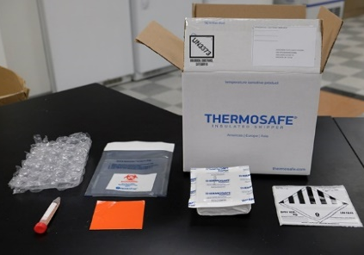
Collect packaging supplies
- This is the shipping kit used by WSLH. If you use a different
shipper it should have similar contents.
- If you do not have a kit, they can be ordered.
  - Clinical orders 1-800-862-1088
- If a cool pack is needed, place it in the freezer ≥24 hr before use.

Package specimens
- Wrap each specimen in its own an absorbent pad.
- Place each wrapped specimen in its own biohazard bag.
  - The bag must have a biohazard symbol on it.
- Seal the bag completely to contain any leaks.

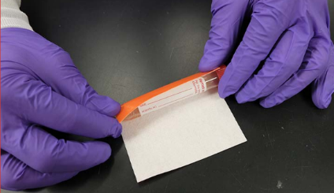

Complete Requisitions Forms
- Forms can be obtained by calling:
  - Customer Service: 1-800-862-1013
- Complete all required information on the form.
- Place the paper requisition in the outer pocket of the bag.
  - DO NOT put it inside the bag with the specimen
  - NEVER staple the form to the bag or puncture the bag.

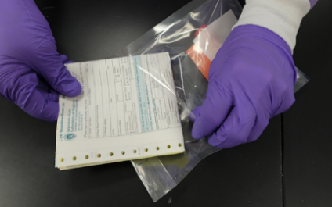

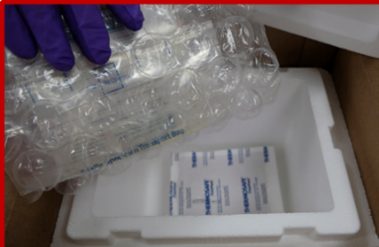
Pack the box
- Add coolant first (if needed)
  - If your specimen(s) require transport at 0 to 20° C use a frozen cold pack (pictured).
  - If your specimen(s) require transport at -80 to 0° C, identify a source of dry ice for shipping.
- Use material such as bubble wrap or crumpled paper to cushion bagged specimens and prevent breakage
- Place lid on the Styrofoam® box. Do not tape this lid shut.
- Seal the cardboard box with one piece of tape. (see blue arrow)
  - WARNING: If shipping with dry ice, taping all sides or storing in a refrigerator creates a bomb!

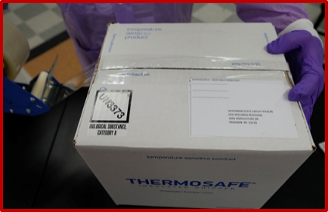

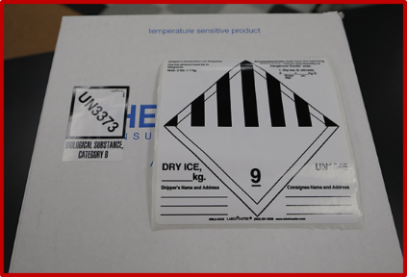
Label the Box
- Add to and from address labels
- All Category B shipments must have a UN3373 label
- If shipping on dry ice, you must also place a dry ice label on the box and write on the label the weight (in kg) of dry ice.
- DO NOT overlap labels or wrap them around corners. Try to place all labels on the same surface of the box.

