***“Let’s Talk Antimicrobial Resistance, Stewardship, and Susceptibility Testing!”***

***(A WCLN Conference for Wisconsin Laboratory Professionals)***

**Tuesday April 1, 2025**

** **AGENDA**

7:45 AM - **Check-in and Refreshments**

8:10 AM - **Welcome, Introductions, and Overview**

* *Austin Fox*

8:20 AM – **Presentation of** **Peter A. Shult Award**

* *LabTAG*

8:30 AM - **Keynote: Reconciling Validation of Mandatory CAP Requirement for Implementation of CLSI Approved Breakpoints against FDA LDT Regulations**

* *Virginia Pierce*

9:20 AM – **Dealing with Genotypic/Phenotypic AST Discrepancies**

* *Rachael Liesman*

10: 05 AM - **Break**

10:20 AM – **FDA LDT and AST Validations – Panel Discussion**

- *Heather Alvarez, Taylor Wahlig, Alexander Lepak, Virginia Pierce*

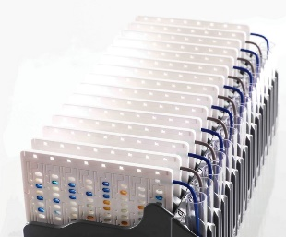 11:10 AM – **Antimicrobial Stewardship**

* *Alexander Lepak*

12:00 PM - **Lunch**

1:00 PM - **Breakout (Pick one)**

**Troubleshooting AST Verification/Validation Issues**

* *Megan Selle, Alana Sterkel*

**Antimicrobial Agent Mechanisms**

* *Erik Munson*

1:50 PM – **Break**

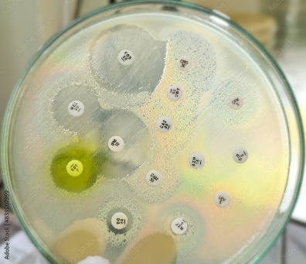 2:05 PM – **Challenges with AST QC (Maintaining Organisms, QC Evaluation and Troubleshooting)**

* *Macy Wood, Caitlin Cahak, Will Laudon*

2:55 PM – **Kahoot Challenge**

* *Alana Sterkel*

3:25 PM - **Final Thoughts**

* *Austin Fox*

3:30 PM - **Adjourn**